**CODING CHALLENGE 4**

1. **1. Update the daily rate for a Mercedes car to 68.**

**Query:** update vehicle

set dailyrate=68.00

where make="mercedes";

**Output:**

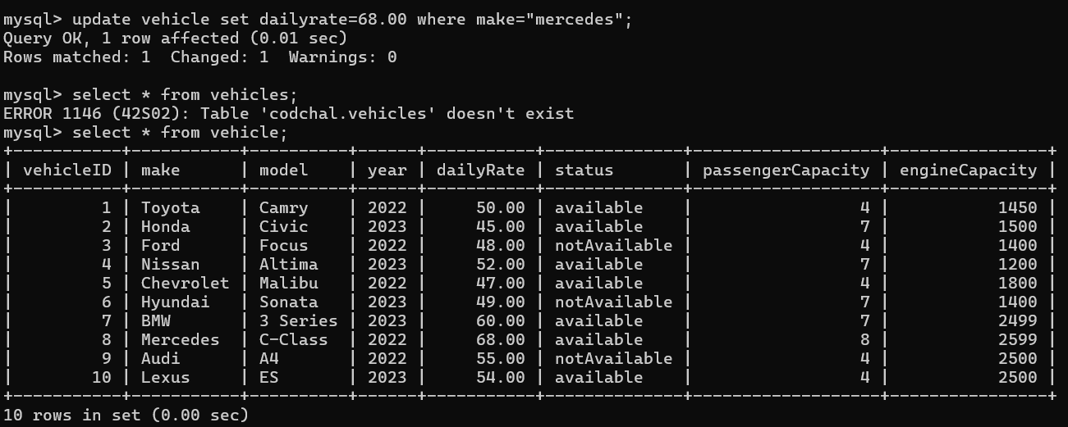

1. **Delete a specific customer and all associated leases and payments.**

**Query:** i) Delete from payment where leaseid=(select leaseid from lease where customerid =10);

ii) Delete from lease where customerid =10;

iii) Delete from customer where customerid =10;

**Output:**

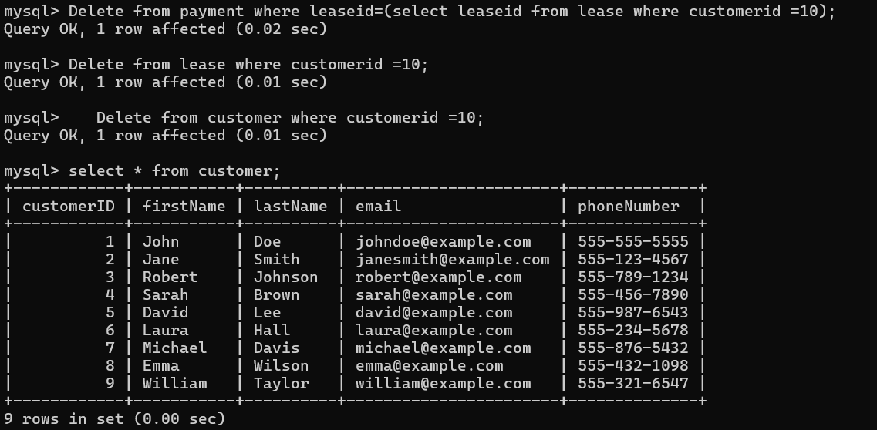

**3) Rename the "paymentDate" column in the Payment table to "transactionDate".**

**Query:** alter table payment rename column "paymentDate" to "transactionDate";

**Output:**

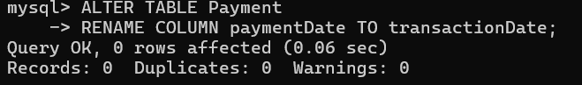

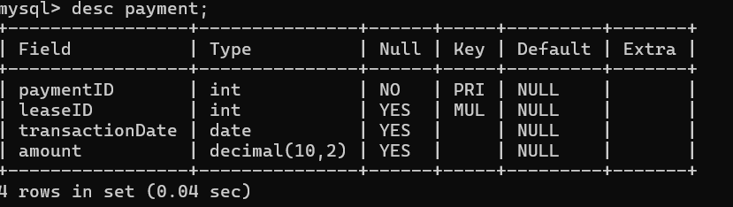

1. **Find a specific customer by email.**

**Query:** select email from customer where firstname="John";

**Output:**

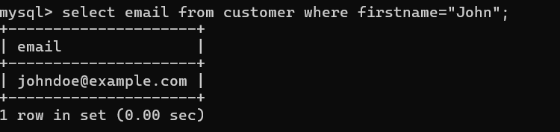

1. **Get active leases for a specific customer.**

**Query:** select l.* from customer c, lease l

where c.customerid = l.customerid

and l.enddate >= curdate()

and c.firstname = 'john';

**Output:**

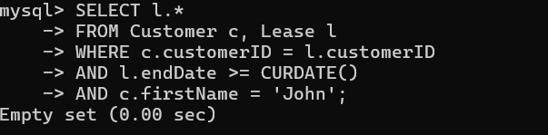

1. **Find all payments made by a customer with a specific phone number.**

**Query:** select p.amount,c.phonenumber from Payment p

join Lease l on p.leaseID = l.leaseID

join Customer c on l.customerID = c.customerID

WHERE c.phoneNumber = '555-432-1098';

**Output:**

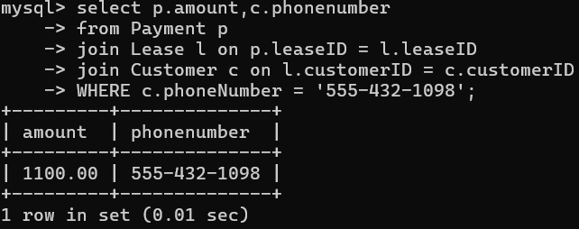

1. **Calculate the average daily rate of all available cars**

**Query:** select avg(dailyrate) as average from Vehicle;

**Output:**

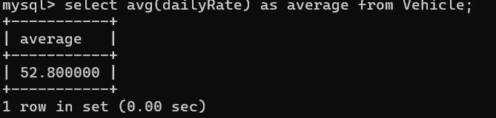

1. **Find the car with the highest daily rate.**

**Query:** select make from Vehicle where dailyRate=(select max(dailyRate) from vehile);

**Output:**

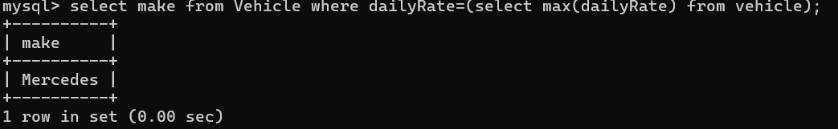

1. **Retrieve all cars leased by a specific customer.**

**Query:** select make from vehicle v where vehicleid =(select vehicleid from lease where customerid=2);

**Output:**

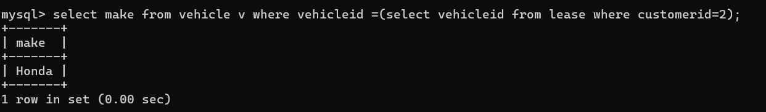

1. **Find the details of the most recent lease**

**Query:** select startdate from lease order by startdate desc limit 1;

**Output:**

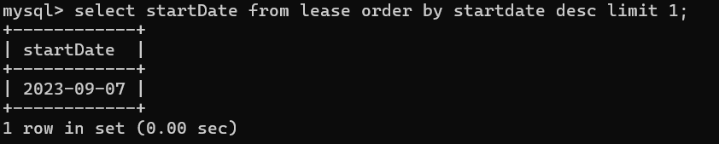

1. **List all payments made in the year 2023.**

**Query:** select paymentid from payment where year(transactiontDate) = 2023;

**Output:**

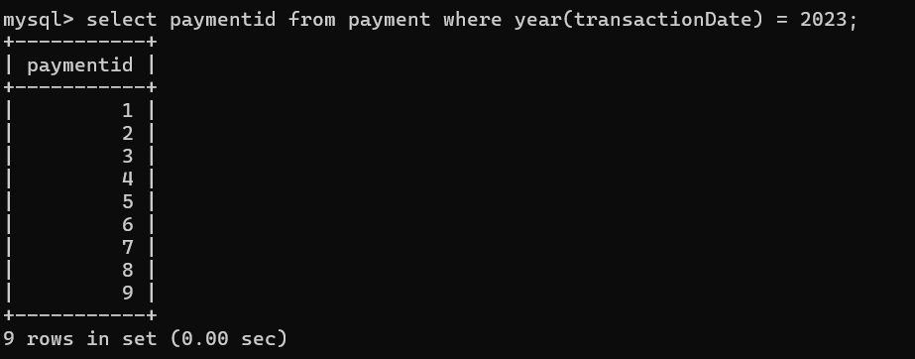

1. **Retrieve customers who have not made any payments.**

**Query:** select c.* from customer c

left join lease l on c.customerid = l.customerid

left join payment p on l.leaseid = p.leaseid where p.paymentid is null;

**Output:**

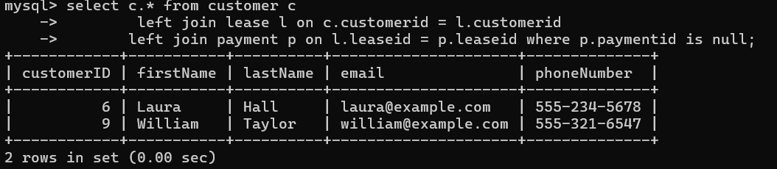

1. **. Retrieve Car Details and Their Total Payments.**

**Query:** select v.*, sum(p.amount)as total_payments

from vehicle v

left join lease l on v.vehicleid = l.vehicleid

left join payment p on l.leaseid = p.leaseid

group by v.vehicleid;

**Output:**

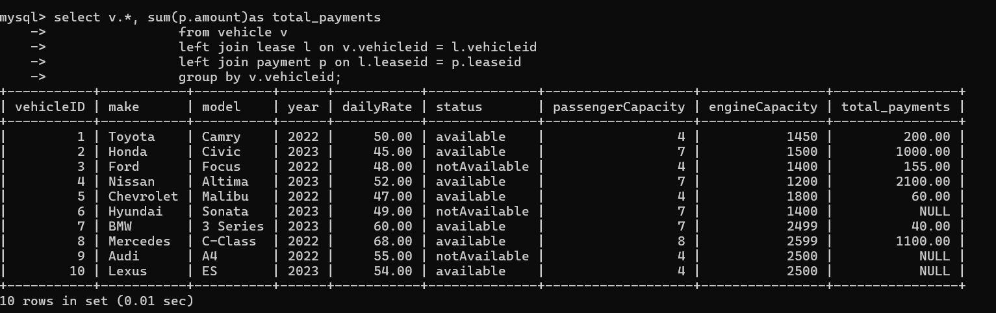

1. **Calculate Total Payments for Each Customer**

**Query:** select c.*, sum(p.amount)

from customer c

left join lease l on c.customerid = l.customerid

left join payment p on l.leaseid = p.leaseid

group by c.customerid;

**Output:**

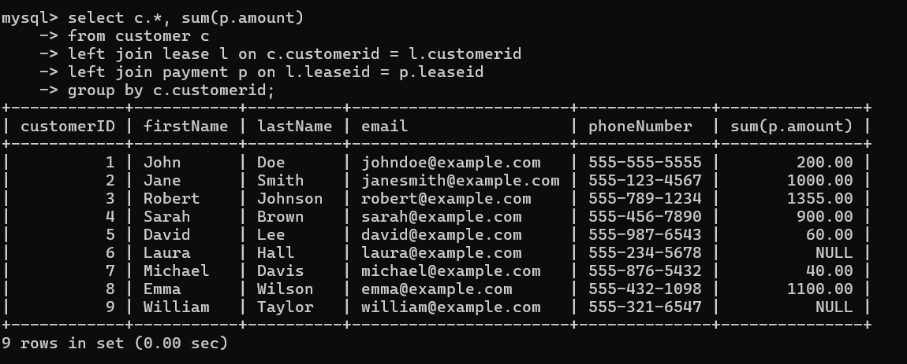

1. **. List Car Details for Each Lease.**

**Query:** select * from vehicle where vehicleid in (select vehicleid from lease);

**Output:**

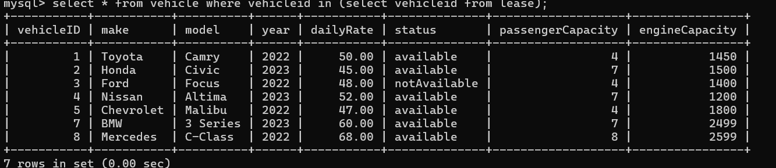

1. **. Retrieve Details of Active Leases with Customer and Car Information.**

**Query:** select * from vehicle where vehicleid in(select vehicleid from leases where endDate >= curdate());

**Output:**



**17) Find the Customer Who Has Spent the Most on Leases.**

**Query:** select * from customer where customerid = (select customerid from lease order by startdate desc limit 1);

**Output:**

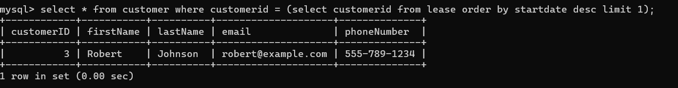

1. **List All Cars with Their Current Lease Information**

**Query**: select v.*, l.* from vehicle v, lease l where v.vehicleid = l.vehicleid;

**(or)**

select v.*, l.* from vehicle v, lease l where v.vehicleid = l.vehicleid

and l.enddate >= curdate() ;

**Output:**

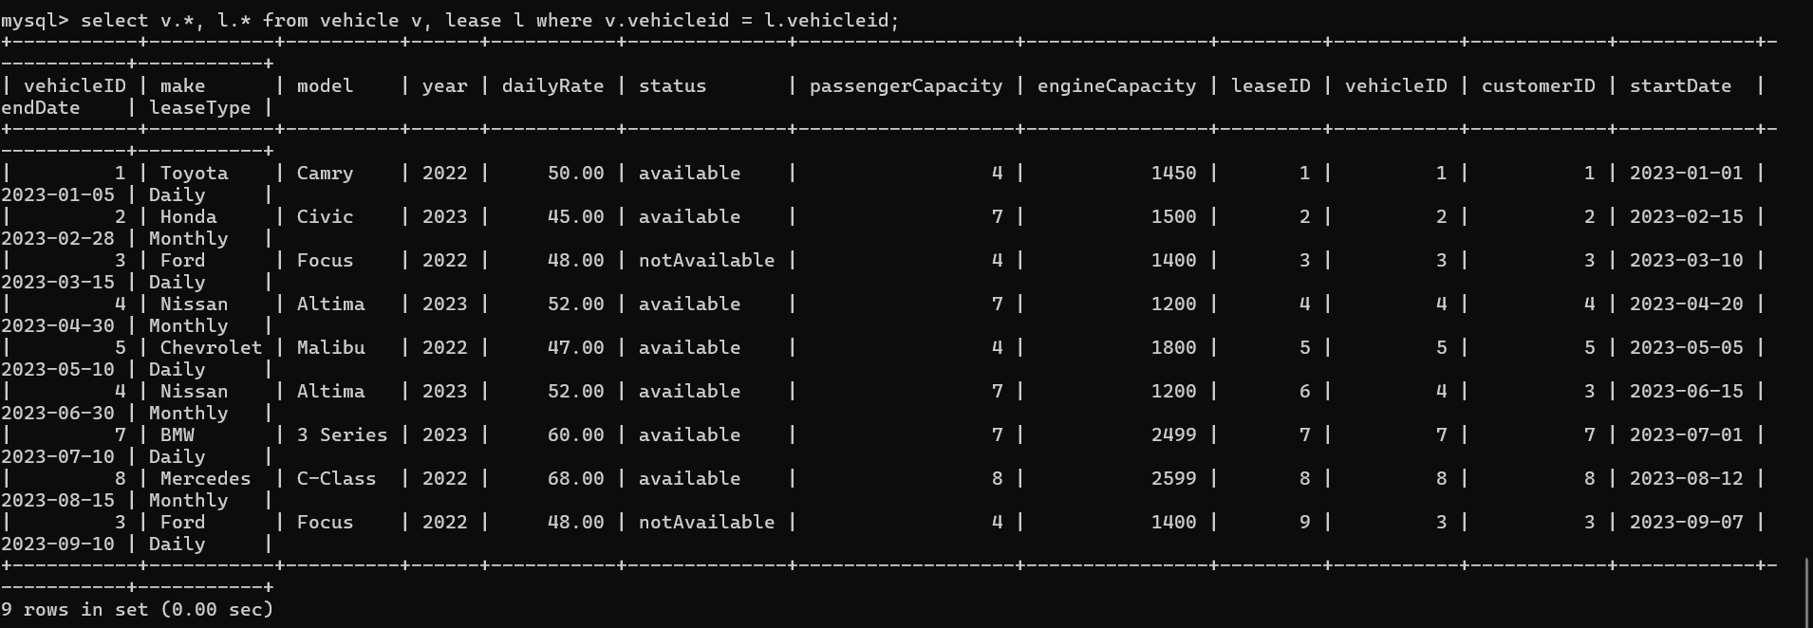

**(or)**

